**Delete an EBS Volume**

* Selecting the EBS volume you want to delete

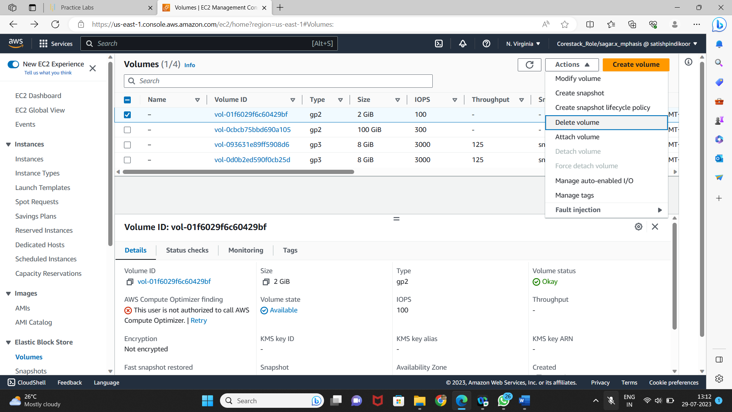

* Deleting the volume

